**ASSIGNMENT**



**Name:**

M.MAZHAR

M. Imran

**Registration:**

FA19-BCS-078

FA19-BCS-070

**Submitted To:**

Sir Abdullah

**Submission Date:**

19-05-2022

**Subject:**

Android Development

**Project Allocation App**

**FLOW CHART**

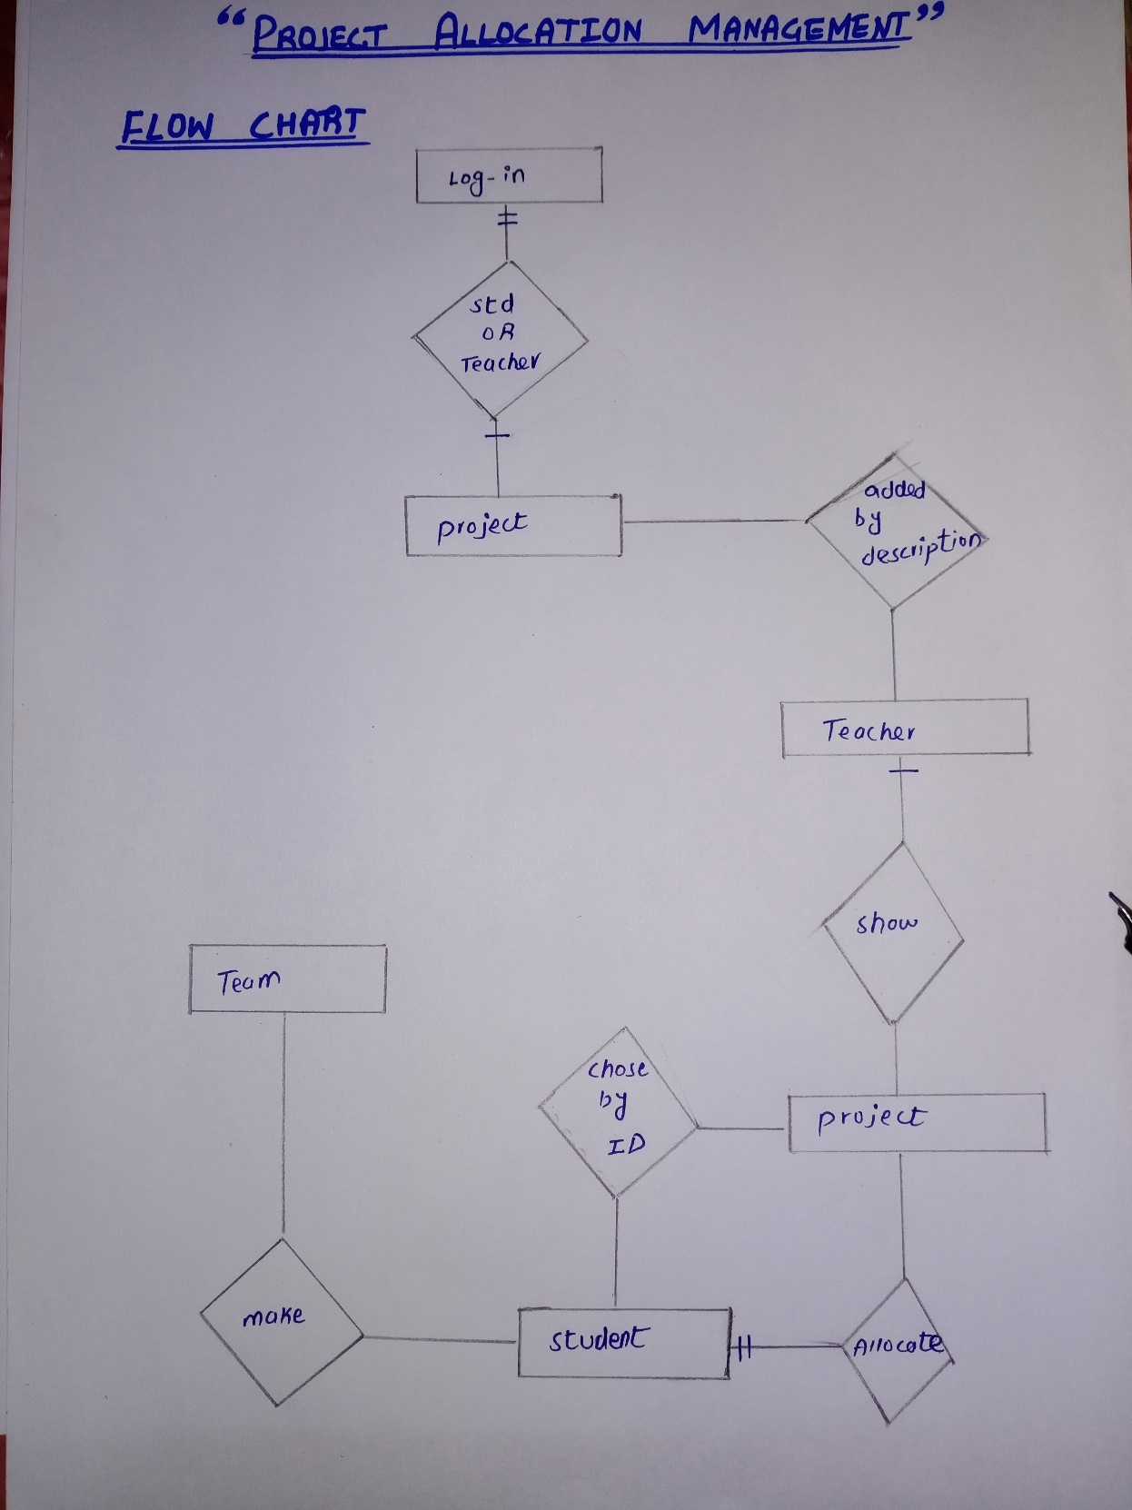

* **Functional requirement:**
* Login page
* Student shall login
* Teacher shall login
* Add project
* Teacher adds project with project description
* Show project
* Teacher shows project
* Allocate project
* Teacher allocates project that are student selected
* Chose project
* Student chose project with project id
* Make a team
* Student make a team
* **Non-Functional Requirement:**
* Security:
* Only authorized users can access the system with username and password.
* Performance:
* Easy tracking of records
* User friendly:
* The system is very interactive
* Maintainability:
* Responsive

**Repository Link**

[**https://github.com/itschmazhar/FA19-BCS-078-M.MAZHAR**](https://github.com/itschmazhar/FA19-BCS-078-M.MAZHAR)

**<https://github.com/itsimran69/flutter>**

